**9. Reactjs-HOL**

**Step 1:** Create a new React app using the command **“npx create-react-app cricketapp”**



**Step 2:** Create 2 Components with names ListofPlayers.js and IndianPlayer.js

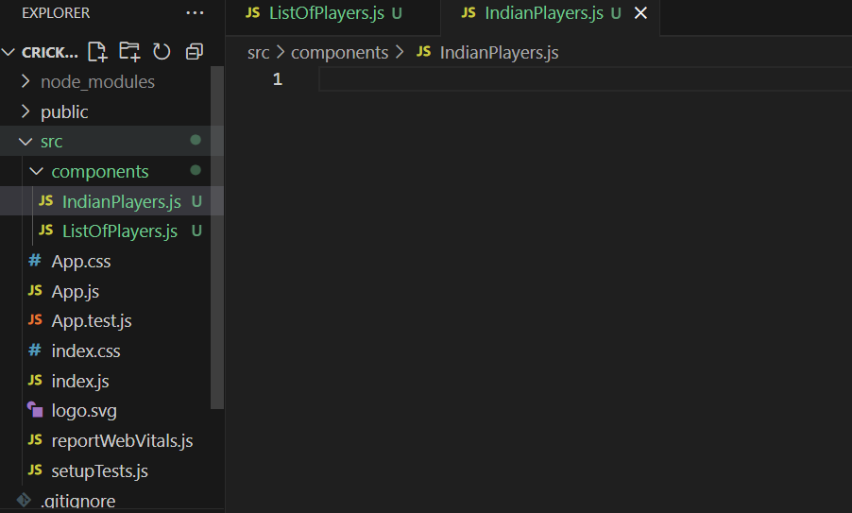

**Step 3:** Then fill the following codes in the two Component files

This is the function that should be written in ListofPlayers.js file, It takes Array of Objects (Players) as Input and displays them as list.

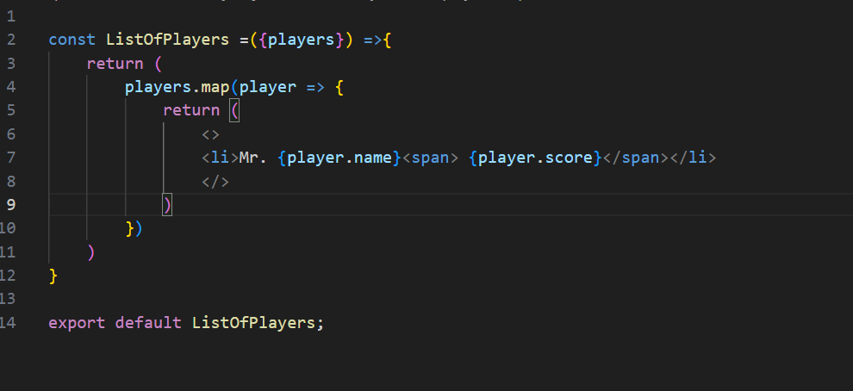

All the code below should be written in IndianPlayers.js file

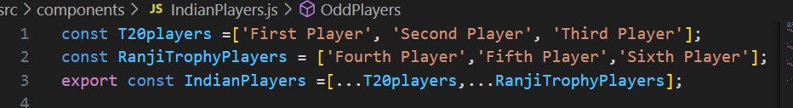

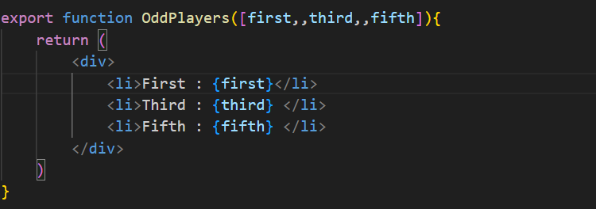

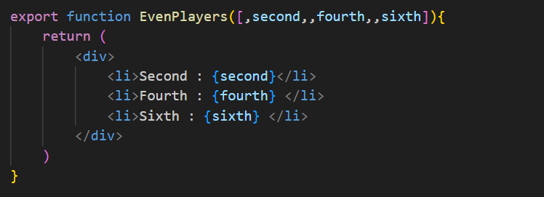

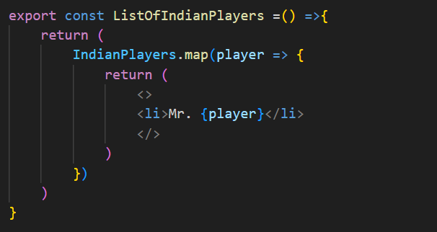

**Step 4:** In App.js File, we create a useState for the Boolean value management, then we use conditional rendering to render the Components on basis of the flag value. We have also created a Button to toggle the value of **Flag** between True and False, So that we can easily Switch the value between **‘True’** and **‘False’**.

function App() {

  const [val,setVal] = useState(true);

  return (

    <>

    {val ? <div>

    <h1>List Of Players</h1>

    <ListOfPlayers players={Players} />

    <hr/>

    <h2>Players With Score less than or equal 70 </h2>

    <ListOfPlayers players={Players70}/>

    </div>: <div>

      <h1>Odd Players</h1>

      {OddPlayers(Indians)}

      <hr/>

      <h1>Even Players</h1>

      {EvenPlayers(Indians)}

      <hr/>

      <h1>List of Indian Players Merged</h1>

      <ListOfIndianPlayers />

    </div>}

    <button onClick={()=> setVal(!val)}> click me!</button>

    </>

  );

}

**Step 5:** You should see the following output on you “**localhost:3000”**

